Lab 4: Oscilloscope, Function Generator, And Capacitors

Possible Points:66

Lab Equipment List:

- Function Generator
- Resistors (Any of the resistors in your kit may be used in these experiments)
- Capacitors
- Breadboard and wires
- Oscilloscope
- Triple Output DC Power Supply

Partnering:

- Everyone must create their own lab report (fill out this document).
- Everyone must build their own circuits, but you may use the same measurement equipment.
- Discussions are encouraged, and you are also encouraged to answer each other’s questions!
- Seek out the TA if you get stuck or need help.

Terminologies:
- DMM: Digital Multimeter
- IC: Integrated Circuit

Lab Procedures:

Welcome to Lab 4! In this lab, you will learn how to use an oscilloscope. Also, in this lab, we’ll learn how to use a function generator, which allows us more flexibility in choosing various source waveforms.

Part 1: The Oscilloscope (11pts)

The oscilloscope is used to view voltages vs. time on a 2-D plot. It is useful for displaying both repetitive waveforms or single pulses, and for determining the amplitude of the signal, frequency, rise time, time interval, etc.

- Watch the two oscilloscope videos that are posted in Canvas (on the page where you found this file). Alternatively, you can watch the longer video that is posted lower on the page.

- Check out an oscilloscope training board from the window. A picture of one is shown in Fig. 1.
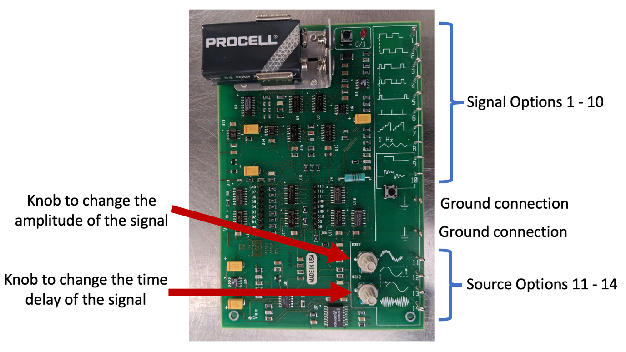
Fig. 1 The oscilloscope training board.

- Turn the oscilloscope on.

- Take out an oscilloscope probe from the drawer (they will be in a grey bag if they have not already been opened). An oscilloscope probe has a Bayonet Neill-Concelman (BNC) connector (see Fig. 2) on one end and a small pencil-like probe on the other. Connect the BNC connector to the first terminal on your oscilloscope.

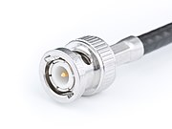
Fig. 2 BNC connector (Courtesy of Swift.Hg). A BNC connector allows us to quickly connect / disconnect coaxial cables to a piece of equipment.

- In the top left corner of the oscilloscope training board, slide the battery so that it is connected to the board. Ensure the red LED is on. If it does not turn on automatically, try pressing the button next to it.

- With the BNC connector of the probe connected to the oscilloscope, let’s now consider the other end of it. First, connect the alligator clip to the ground on the training board (see Fig. 1). Then we want to connect the pencil end of the probe to the signal we want to measure. If you pull back on the sleeve of the probe, a small hook will become visible. Hook that onto Signal 1 (a periodic sequence of step functions).

- By default, the signal should become visible on the oscilloscope screen (although it won’t look like the signal we want yet). If it does not, you can turn on each numbered signal by pressing the corresponding button on the right hand side of the oscilloscope. If the number is lit, that channel is on.

- To get a reasonable view of the signal, press the “Autoscale” button (located in the top right corner). With the signal now much better displayed, we can begin to work with this signal. Attach a picture of the oscilloscope’s current look below. (9pts)

<attach the picture here >

- First we will consider the vertical scaling. In the top bar, you can see the increment that is being used (such as 5 V/, meaning that each division on the screen represents 5 V). This is a property that can be adjusted for each channel individually, and each will show up next to the corresponding channel number. To change this scaling manually, use the large knob above the channel you wish to change. Pushing the large knob will change how large of increments are taken (as in, coarse vs. fine adjustment).

- The small knob below the channel number will adjust where ground (as in 0 V) is on the screen. Turn this knob and notice the ground indicator on the left side of the screen moving up and down to show where 0 V is. Pushing the small knob will put 0 V back in the center of the screen.

- Now, we will adjust the horizontal axis, which is controlled using the large knob in the “Horizontal” section in the top left corner of the button panel. This knob works very similar to the vertical adjustments above, and pressing the knob will allow for fine adjustments. As you adjust, notice the timescale in the middle of the top bar change (for example, 100 $μ$s). This will tell you the time between ticks in the horizontal direction. Note that this is not something that is set per channel, rather the entire screen is scaled by this. You may also find it useful to use the small knob in the horizontal section, which changes the portion of the wave you see. You may see the time adjustment in the top bar as well, if it is important. Pressing this knob changes the adjustment to zero. Please attach the current picture of the oscilloscope below. (2pts)

<attach your picture here >

- You may find it occasionally helpful to have a very detailed view of a certain part of the waveform. To do so, press the magnifying glass icon. The screen will split in two, providing you a much finer time scale for looking at the waveform, which is controlled by the two horizontal knobs. Press the magnifying glass to exit the zoom functionality.

- BEFORE YOU MOVE ON: ensure that you understand by using the gridlines to measure this signal (and perhaps a few others, such as signals 2, 5, 7, 8, and 12). Depending on the signal you are measuring, you should be able to adjust the scaling so that you can easily estimate the peak to peak voltage, period, frequency, time between pulses, etc.

Part 2: The Oscilloscope Trigger (6pts)

- When the oscilloscope draws the signals in its normal mode, it generally does not do them in real time. Instead, it takes a small snapshot of what is occurring. In order for the oscilloscope to know when to take the snapshot, we use the trigger. By default, the trigger is any rising signal at 0 V (meaning any signal that passes 0 V will start a snapshot), but it can be changed by auto scale to help ensure that the signal is displayed properly. There are a LOT of options to help customize the trigger in order to provide good signals, so we will only show a small section of what is available.

You can see what the trigger options are by looking in the top right hand corner. To get to the trigger options, press the “Trigger” button in the Trigger zone. You will notice that the menu at the bottom of the screen changes. The options here allow you to change the channel that performs the trigger as well as the type of trigger. To change these options, press on the button underneath the menu item you want to select it. Although you can make selections exclusively using these buttons, the easiest way will instead be to use the knob in the grey box just under the trigger function, which allows you to easily scroll through all of the options. You can press the button to select.

- Let’s try using the trigger. Change the trigger to be from triggering on an upward slope to on a downward slope. Press the button underneath the picture of a signal with an arrow pointing up on it, and do a menu select to the option in which the arrow is pointing down. You will notice that the entire signal shifts because the time when the trigger happens is different. Attach the current picture of the oscilloscope below. (3pts)

<attach picture here >

- You can also vary the voltage at which a trigger occurs. The small knob in the trigger section allows this functionality. To show this functionality well, move your probe to Signal 8 on the oscilloscope training board. Try moving the trigger voltage to above or below the waveform. You will notice that the waveform moves as the time in which the trigger occurs changes, but no updates will occur if you move the trigger voltage above or below the waveform.

- As a final note for this section, check out the run/stop button and the single button in the top right corner. Pressing the run/stop can pause the oscilloscope intake, while the single button will wait for exactly one trigger and display the result. Try this out by using Signals 9 or 10, which only turn on when you press the button below them. Please attach the current picture of the oscilloscope below. (3pts)

<attach here >

BEFORE YOU MOVE ON: Ensure that you understand how the trigger works and can do it with a variety of waveforms. You may try the same ones as above.

Part 3: Take Measurements of Signals using the Oscilloscope (5pts)

- The last section concerns measuring with the oscilloscope. Although using the gridlines can be an easy way to find quick estimates, they are rarely very good. One easy way to do this is to use cursors. In the measure section of the oscilloscope, press the cursors button. You will notice that a new software menu appears that will allow you to customize the way these work. Ignore this for now, and use the small knob to move the dotted lines along the waveform (pressing down to change between the two selections). The output values can be seen in the menu to the right. Using one of the training board signals from before, make sure you can find the period, frequency, or peak-to-peak voltage using this method.

- Perhaps the easiest way to measure items is to press the “Meas” key in the measure section. This will bring up another software menu and a variety of measurements generated by the oscilloscope itself. For this, connect two probes to Signals 12 and 13. The measure function should have a few measurements brought up by default, but it can do much more than that. The bottom bar contains a variety of options to select for a new measurement. In general, select the source channel, then use the type key to scroll through the variety of options the oscilloscope can measure. For now, look at the peak to peak voltage, period, and frequency of Signal 12. Once you have the measurements up, turn the top knob on the training board (see Fig. 1) to vary the amplitude of the wave. Attach the current picture of the oscilloscope below. (5pts)

<attach the picture here >

- To complete the experiment, add the time difference and phase measurements between the two signals, then turn the bottom knob on the training board (see Fig. 1) to vary this value.

- BEFORE YOU MOVE ON: Ensure you understand how to measure signals using both the cursors and the in-built measurements. Call over your Lab TA, who will check off your knowledge of the oscilloscope.

Part 4: The Function Generator (12pts)

The function generator is a device that allows us to create waveforms to use in our circuits on the fly. We will use this a lot in the remaining labs to allow us to see the effect of different waveforms on our circuits.

- The function generator has two BNC outputs on it, which are the same cable types that the oscilloscope uses. Connect the “Output” port of the function generator to the oscilloscope by using a BNC to BNC cable, or by using a BNC to a clip that is connected to an oscilloscope probe.

- The other function generator output provides an easy sync to the generated waveforms, which is useful if the circuit you are building creates outputs that do not easily trigger the oscilloscope. You can ignore this output for now.

- Turn on the function generator. You will notice that it will begin outputting right away (probably as default a 1 kHz sine wave). Attach the current picture of the oscilloscope and your function generator below that also show BNC cables. You may attach one or two pictures that shows your work.(6pts)

<attach the picture here >

- Autoscale is your friend here, make sure you can see the waveform output. Also put measurements on the waveform for frequency and peak to peak voltage.

- You can adjust the frequency of the output wave by pressing the “Freq” button in the bottom row and by using the large knob located on the screen. As for the DC power supply, you can change which digit is selected using the left and right keys next to the outputs. If you have gone into a different menu and need to get back to frequency, you can press the “Freq” button again.

- Similarly, you can change the amplitude of the output by pressing the “Ampl” button in the bottom row. You should notice that the voltages measured by the oscilloscope turn out to be double what the function generator says it is putting out. This is due to a very interesting design choice by the people who made these function generators, which assumes that the load you have attached to it is 50 Ω (i.e. R_{L} = 50 Ω). That is, internally, you can think of the function generator as being a Thévenin equivalent circuit with R_{th} = 50 Ω. When the output resistance (the load) is 50 Ω, the Thévenin voltage source (V_{Th}) needs to generate double the requested voltage due to the voltage divider between R_{th} = 50 Ω and R_{L} = 50 Ω.

Fig. 1 Thevenin equivalent circuit for the function generator along with the assumed load attached to the function generator.

If the load resistance is higher than 50 Ω, the output voltage will similarly be higher (due to the voltage divider between R_{th} = 50 Ω and R_{L} > 50 Ω). The voltage shown on the oscilloscope may go up to V_{Thevenin}, which is 2x the voltage displayed on the function generator. Although 50 Ω is the only choice on our oscilloscope, many newer models allow you to set a variety of output resistances instead, which makes them a little more user friendly.

- The top row of buttons displays various waveforms that may be useful. Press several and see how they work. Attach the current picture of the oscilloscope and function generator that also show BNC cable. You may attach one or two pictures that shows your work. (6pts)

<attach the picture here >

- Come up with a few configurations (different wave types, voltages, and frequencies), and prove to yourself that you understand how to use this piece of equipment.

Part 5: Simulate the Behavior of a Capacitor (Charging and Discharging) (21pts)

General background information on capacitor types and construction

Capacitors are one of the basic building blocks of electrical circuits. Capacitors with values less than 1 μF are usually constructed by layering sheets of metal foil and insulating material. Often these sandwiches are rolled into little cylinders (as shown in Fig. 2) or flattened cylinders. The metal foils are the plates of the capacitor and the insulator is the dielectric. The dielectric material determines the capacitor type (paper, mylar, ceramic, etc.).

Capacitors come in many shapes and a huge range of sizes. The value of a capacitor is proportional to the area of the plates and inversely proportional to the thickness of the dielectric material between them. In general, a capacitor with a larger capacitance value will have to be physically larger as well.

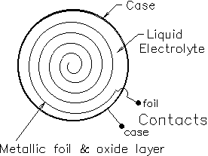
Fig. 2 A capacitor constructed by layering sheets of metal foil and insulating material, which are then rolled up into a cylinder.

Many small capacitors are marked with numbers like 104K or 471M. The numbers are read like the bands on a resistor — two digits and a multiplier that indicate pico-farads (104 is 10 x 104 pF = 0.1 μF or 471M is 47 x 101 pF). The letter indicates the tolerance (how accurate we can expect the actual capacitance to be relative to the label on the capacitor), F = ±1%, G = ±2%, J = ±5%, K = ±10%, M = ±20%. Check out the capacitor value information posted in Canvas on the “Lab Help and Resources” page.

Capacitors with values greater than 1 μF are usually constructed by immersing a roll of metal foil in a conducting liquid called an electrolyte. These types of capacitors are called electrolytic capacitors. The foil is one plate and the liquid is the other. The dielectric is a very thin layer of oxide formed on the foil. Because the oxide layer is so thin, electrolytic capacitors can have very large values in relatively small packages. Unfortunately, the oxide dielectric also gives them some other, less desirable, characteristics.
- Most electrolytic capacitors can only be charged with one polarity. Voltages of the wrong polarity can damage the oxide layer and sometimes even cause the capacitor to blow up. When you build a circuit with capacitors, ask your TA if you’re not sure how to connect the capacitor to the circuit .
- They are difficult to manufacture accurately and their actual value may differ from their claimed value by as much as a factor of two (-50%, +100%).
- The oxide is not the best of insulators, so they can have significant leakage current.
- They may not be very fast for high frequency applications.
- The oxide layer is so thin that electrolytic capacitors have relatively low voltage ratings.

- We will first use LTSpice to see the charging and discharging of a capacitors. Open Lab5ChargeDischarge.asc, which has the circuit shown in Fig. 3. However, note that this is a transient simulation. After a one second delay, the voltage source produces a 10 V pulse for 5 seconds, and then it turns off for 6 seconds (so the entire simulation is 12 seconds long).

- Run the simulation. This will pop out an empty graph that can be used to display data (and since this is a transient simulation, it will plot values over time instead of giving single values). You can gather plots of what is occurring in the simulation by clicking on various parts of the circuit. Clicking on wires allows you to get the voltages (in reference to ground) at any point in the circuit, while clicking on components will allow you to measure the current through those components.

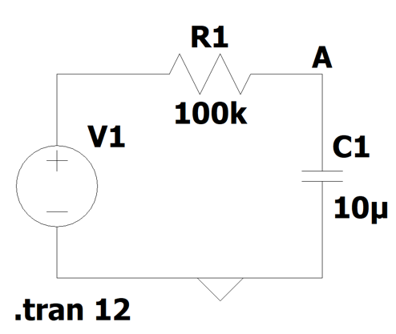
Fig. 3 The circuit we will analyze. (.tran 12 stands for transient analysis for 12 seconds, meaning the full simulation lasts 12 seconds).

- Examine the voltage across the capacitor (the voltage at A) and the current through the capacitor. Put a copy of the current and voltage plots below. (3pts/unit=6pts)

<put the graph here>

- Now examine the behavior of the voltage and current in the plots. For the charging portion of the graph (aka, the voltage is going up), we can see that the voltage follows a path that reaches an asymptote. We can also see that although a lot of current flows into the capacitor at the beginning, as it charges, the current decays to zero. What is happening to the circuit during the charging and discharging cycles to generate the behavior you see in the plot? What is it about capacitors that causes this action? (4pts)

<fill in >

- Fill in this sentence: “For capacitors, the ____ (voltage / current) cannot change instantaneously. However, the ____ (voltage / current) can change instantaneously. Hint: Remember the voltage-current relationships for a capacitor. The capacitor’s voltage (electric field) can change quickly, but the capacitor won’t reach it’s max voltage (electric field value) quickly. (2pts/unit=4pts)
$i_{C}=C\frac{dv_{c}}{dt}$
$v_{C}=\frac{1}{C}\int_{-∞}^{t}{i_{C} dt}$

- This shape of these graphs is common to a group of systems that are called “first order systems”. These systems (which can be represented by a linear time invariant first order differential equation) have the specific response of increasing/decreasing to an asymptote as shown in Fig. 4. To categorize and understand these systems, we can use a measure called the “time constant”. The time constant 𝜏 (tau) is the amount of time that is required for a system to reach 63.2% of the way to the asymptote from the starting value. As an example, for the charging portion of the circuit (going from 0 V to 10 V, the time constant would be the time it takes to reach 6.32 V. For the discharging portion (going from 10 V to 0 V), the same time can be found between the time the voltage begins to fall and when the voltage falls to 3.68 V. The time constant for our circuit is 𝜏 = RC. Find the time constant of the circuit shown in Fig. 3 using 𝜏 = RC and record your results below. Note: The pulse is delayed by 1 second in the simulation. As a result, in order to calculate the correct 𝜏, make sure you take this into account when you use the value you see on the x-axis. (5pts)

<fill in >

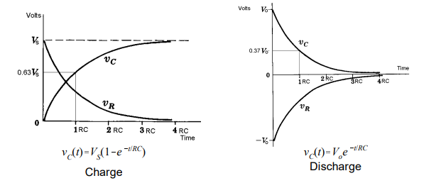
Fig. 4. Voltage across the capacitor (V_{c}) and resistor (V_{R}) in an RC circuit during the capacitor charging / discharging vs. the number of time constants.

- Does your answer for the time constant in Step 6 agree with the simulated results shown in your plots from Step 3? (2pts)
<fill in >

Part 6: Measure the Behavior of a Capacitor (Charging and Discharging) (11pts)

- Let’s apply our knowledge building a circuit. Build the circuit, using R = 1 kΩ and C = 0.1uF (label should read 104). Connect them in series as similar in Fig 3. If you’re using an electrolytic capacitor, make sure you do not connect it backwards! Remember that they have + and – leads as shown in Fig. 5.
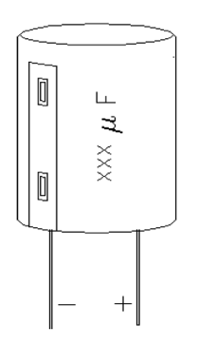
Fig. 5 Diagram of an electrolytic capacitor with the + and – leads labeled.

- What should the time constant be for this circuit? (5pts)

<fill in >

- The function generator will serve as the source for your circuit. Use it to generate a square wave with a period of more than 3 times the time constant (remember, frequency is 1/period; also, the period describes one complete on/off cycle of the square wave, i.e. the square wave can be described by sgn$\left[sin⁡\left(\frac{2πt}{T}\right)\right]$, where sgn is the sign function (Google this if needed).

- Connect your scope to point A (see Fig. 1), and set it up so that you see a single waveform showing the charging of the capacitor. Once you have the waveform, use the cursors to find the time constant.

- What is the measured time constant and how does it compare to your analytically-calculated time constant in step 1 above? (4pts)

<fill in >

- Did the circuit behave as expected? (2pts)

<fill in >

- Before you tear down your last circuit and leave the lab today, make sure to have your Lab TA check off your lab by showing what you accomplished and demonstrate that you understand the concepts shown here.

- Turn in this completed report to Canvas by the due date.

- Put all of the lab supplies away, including your own lab kit and anything you may have checked out!

