Circuit System Design Cards: a system design methodology for circuits courses based on Thévenin equivalents
Neil E. Cotter, Member, IEEE, and Cynthia Furse, Fellow, IEEE
Abstract—The Circuit System Design cards described here allow students to design complete circuits with sensors and op-amps by laying down a sequence of cards. The cards teach students several important concepts: system design, Thevénin equivalents, input/output resistance, and op-amp formulas. Students may design circuits by viewing them as combinations of system building blocks portrayed on one side of the cards. The other side of each card shows a circuit schematic for the building block. Thevénin equivalents are the crucial ingredient in tying the circuits to the building blocks and vice versa.

Index Terms—Linear, circuit, system design, cards, Thevénin equivalent

INTRODUCTION
T
HE deck of 32 Circuit System Design (CSD) cards allows users to design complete circuits by laying down cards in sequence from left-to-right. The cards have two sides: a system design side (with red-hatched surrounding and yellow background) and a circuit schematic side (with white background). On the system design side, the processing of signals is represented by mathematical operations such as addition or multiplication, or by logic operations such as AND and OR. The user may design a system using only the system side of the cards and then flip the cards over to see the circuit schematic and detailed formulas for deriving resistor values that will yield desired additive factors and gains.
Ideally, the transfer function of each block in a system design would be independent of the preceding and succeeding blocks. For circuits, however, connecting a second block to the output of a first block may cause loading that changes the output voltage of the first block. A unique feature of the CSD cards is that they account for these loading effects while retaining the system design motif. For linear system design, the CSD cards give exact formulas for calculating the voltages in a system in the presence of loading, and the calculation proceeds left-to-right, like the system design.
The key idea underlying the design of the CSD cards is the Thévenin equivalent, i.e., a circuit model consisting of a series voltage source and resistance, and the realization that the signal being processed in the system design is the Thévenin equivalent voltage rather than the circuit output voltage per se. Furthermore, the Thévenin equivalent may be extended from one card to the next, moving left-to-right, with pre-calculated formulas.
This paper discusses how the cards are used and the theory on which they are based. The next section discusses one card in detail, and the following section discusses a two-card system. The final sections catalog the symbols incorporated on the cards and the entire set of card images.

One-Card Example
One side of each CSD card shows a system view of how the card processes its input signal. Fig. 1(a) shows the system side of the Voltage Reference card that produces an output voltage, vTh, from a power supply voltage, VCC. Fig. 1(b) shows the circuit side of the Voltage Reference card with the circuit diagram and formulas in terms of resistor values.
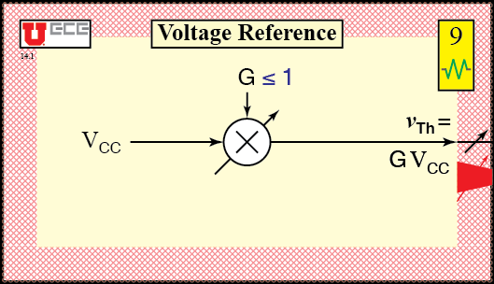
(a)
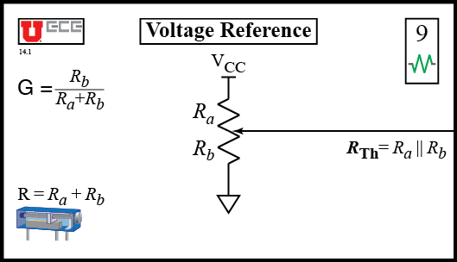
(b)
Fig. 1. Voltage Reference card. (a) System side, (b) Circuit side.
As the system side of the card (with yellow background and read margin) shows, the input voltage, VCC, is scaled by gain, G. The formula for the Thévenin equivalent output voltage, vTh, is shown next to the output and represents the system output value.
(1)
The arrow through the multiplier indicates that the gain is adjustable (by a potentiometer on the other side).
The symbols in the right margin indicate how cards interact. The black arrow on the output line indicates that the gain on this card is adjustable. The card also has the beginning of a large red arrow with a smaller arrow through it in the right margin.red. This marking indicates that the Thévenin output resistance is significantly larger than zero and may affect the gain of the next card, (if the input resistance for that card is too low). If the next card has a low input resistance, the base of the red arrow will be continued on the next card to form a complete red arrow. In that case, the Thévenin equivalent resistance will have to be taken into account in the system response.
On the circuit side of the Voltage Reference card, the formula for the Thévenin equivalent output resistance is shown near the right edge.
(2)
where the parallel operator, ||, is used as a shorthand for the calculation of parallel resistance:
(3)
The formula for gain G, found in the upper left, is revealed to be the voltage divider ratio of resistors.
(4)
Resistors Ra and Rb, constituting the potentiometer resistance, R, affect both the gain, G, and the Thévenin output resistance, RTh. A change in the Thévenin output resistance may change the behavior of the next card.
Note that the entire Voltage Reference card is equivalent to a voltage source of value vTh in series with a resistance of value RTh, although the Thévenin equivalent circuit is not explicitly shown. By itself, the Voltage Reference card tells the user how to convert the voltage divider circuit into its Thévenin equivalent, making it a useful reference tool. However, the cards become even more powerful when the system design is extended by appending cards on the right.

Two-Card Example
Fig. 2 shows a two-card system design for a negative-voltage-reference circuit with low output resistance. On the system side of the cards, the Thévenin output voltage of the first card (on the left) is the input of the second card (on the right). The input of the second card is denoted as vTh<. The "<" symbol in the subscript means "from the card to the left".
The transfer function for the entire system is found by calculating the transfer functions from left-to-right. The output of the first card is given in (1) above. Thus, our input to the second card is given by (5).

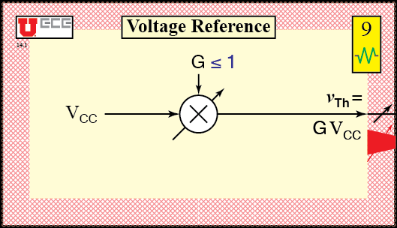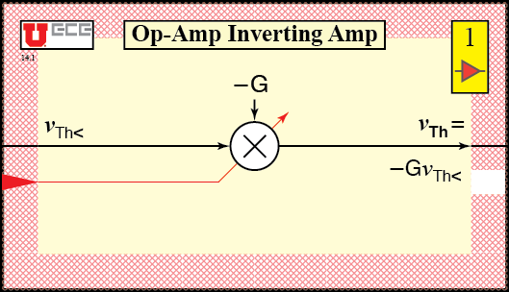
(a)
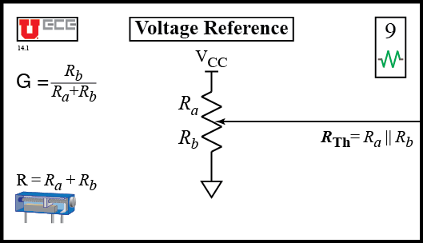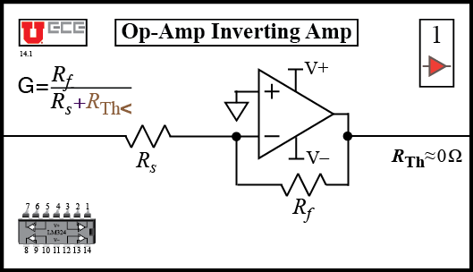
(b)
Fig. 2. Two-card system design for negative-voltage-reference circuit with low output resistance. (a) System side, (b) Circuit side.

(5)
The gain, G, listed in (4) and repeated here is given on the circuit side of the first card.
(6)
The second card multiplies the value in (6) by a second gain, also denoted by G, yielding the output value of the entire system.
(7)
The gain, G, shown on the system side of the second card depends on the Thévenin resistance of the first card, as indicated by the large red arrow in the margins between the cards and the small red line and arrow passing through the multiplier on the second card.
The formula for G shown on the circuit side of the second card shows the dependence on the Thévenin resistance of the first card, the latter being denoted by RTh<, which is given by (2). Using (2), we have the gain formula in (8) for the second card.
(8)
Substituting (8) into (7) yields the formula for the entire circuit's Thévenin equivalent output voltage.
(9)
The designer is now free to choose values for resistors to achieve a desired output value for a given power supply voltage, VCC. Since the gains depend on ratios of values, which is typically the case with op-amp circuits, answers are non-unique. The designer must choose practical resistor values that limit currents and noise to reasonable values. Values from 10 kΩ to 1 MΩ are work satisfactorily for op-amp circuits.
A final note on the system design is that the Thévenin output resistance is approximately zero since op-amps have low output resistance. The circuit side of the second card explicitly lists the Thévenin output resistance as approximately zero. The system side of the second card indicates the Thévenin output resistance is approximately zero by having a white (or blank) box in the right margin. The presence of a blank box on either the input side (high resistance) or the output side (low resistance) breaks the chain of dependence of gains on previous cards.
In other words, the blank box blocks arrows and means the RTh< value from the previous card may be ignored. Cards may then be treated as independent steps in the system design, dramatically simplifying designs. For introductory op-amp designs, students may insert an Op-Amp Buffer (V-Follower) card, shown in Fig. 3, between circuit stages to block Thévenin resistance dependencies.
(a)
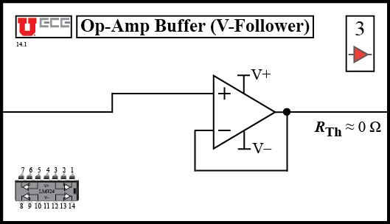
(b)
Fig. 3. Op-Amp Buffer (V-Follower) card.
(a) System side, (b) Circuit side.

Card Symbols and Notation

Overview
Fig. 4 shows features on the circuit side of a card, and Fig. 5 shows features on the system side of a card. The following subsections describe variations in the features.

Card Suits and Numbers
CSD cards come in four suits: Wire (), Component (), Amplifier (), and Gate(). Suits may also be abbreviated as the first letters: W, C, A, and G respectively. With the exception of the "W", these are the same letters as appear in the base pairs of DNA. The authors have avoided the temptation to promote this analogy, however.

Notation for Recursive Thévenin Equivalent v and i
As noted above, the "<" symbol means "from the card to the left". When there are two inputs to a card, a "1" or "2" subscript is added, and the Thévenin equivalent voltage inputs are labeled on both sides of the card. The corresponding Thévenin equivalent resistances also have a "1" or "2" subscript.

Using Multiple Rows
When cards have two inputs, the second input comes from below, implying that circuits may have more than one row. The right-angle wire card is used to bring the signal in from the bottom. A system could also have more than two rows, but another wire card from a second set of cards would be required.

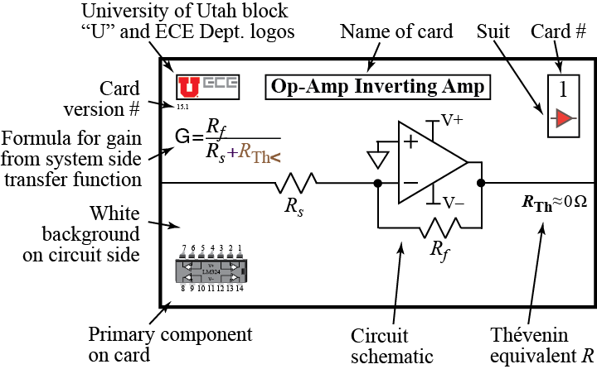
Fig. 4. Circuit System Design card circuit-side elements.

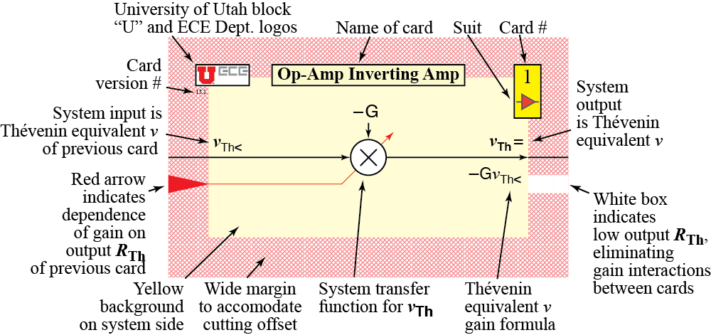
Fig. 5. Circuit System Design card system-side elements.

Calculating Transfer Functions Given Gain Constraints
One challenge for students is determining which cards can provide a given gain formula, especially with two inputs. The challenge arises from the constraints on gains that are listed on the system side of the cards. Students may be given transfer function problems that involve only the system side of the cards, which separates the mathematical system problem from the circuit design problem.
All gains on cards are positive numbers. Negative gains are indicated by adding a minus sign in front of the gain on the system side of the card.

Large Arrows and Boxes in Margins
On the system side of the card, arrows or boxes in the margin indicate interactions between cards that affect gains, owing to Thévenin equivalent resistances. The meanings of the arrows and boxes is as follows:
1) large red arrow formed by adjacent cards = interaction.
2) red box = interaction from previous card is forwarded to next card, possibly completing a large red arrow over three cards.
3) white box = interaction from previous card is blocked, so gains are determined only by the circuit on the card itself.

Arrows for variable gains
Red arrows on the input side of a card lead to small red lines and arrows that indicate which gains on a card are affected by which Thévenin equivalent resistances of previous cards.

Op-Amp Differential Amp Formulation
The Op-Amp Differential Amp card allows for analysis of circuits with mismatched input voltage dividers. Normally, the input voltage dividers will be matched, and the system path shown in gray for the E (for error) signal will be zero. Nevertheless, the E term is available if error analysis is desired.

Black arrows in margin on output wires
Black arrows on output wires indicate a variable output arising from the presence of a potentiometer on the card. Changing the output voltage may also change the Thévenin equivalent resistance.

Component picture in lower left on circuit side
To help beginning students understand circuits they build on breadboards, pictures of the primary component on each card is shown in the lower left-hand corner on the circuit side. Though small, the component pictures of integrated circuits also show pin numbers.

How to print and cut cards
The Adobe Illustrator® file for the cards is set up for printing eight two-sided cards on a page. By turning layers on or off, pages may be printed from Illustrator itself. The top layer in the file contains instructions for printing.
A small set of eight cards may be used for covering just op-amps. These cards are useful as references for the various types of op-amp amplifiers.
The outer box on the circuit side of the cards serves as a cut line. The wide, red, hatched margin on the system side is intentionally made larger than necessary to allow for a mismatch in the registration of the images on the two side of the cards.

Assembly and use of Level-shifter Card
The Op-Amp Level Shifter can translate low and high input voltages into different low and high output voltages. The complexity of the equations for the level shifter necessitated the use of two cards. The two cards may be taped on one edge to create a single hinged card that swings open to reveal the equations for the level shifter design. The suit and number are dimmed on the sides of the level shifter cards that go on the inside when the level shifter card is closed.

Conclusion
The CSD cards allow the user to design simple circuit systems by laying down cards from left to right representing common circuit building blocks such as voltage sources, resistors, op-amps, logic gates, and LED's. On the system side, the cards show Thevenin equivalent voltages being altered by additions and multiplications to create a final output value that may be displayed on an LED or used to run an output device. On the circuit side, the cards show the formulas, in terms of component values, for the additions and multiplications from the system side. These formulas allow the user to complete a circuit design.
Examples presented in this paper illustrate the design process for an LED temperature indicator and show how the cards may be used to find Thevenin equivalents of basic circuits. In each case, the key idea is to collapse a circuit into a new Thevenin equivalent after adding a system (or circuit) block to its output. Formulas on the right side of the circuit side of the cards indicate how to do this.
By processing Thevenin equivalent voltages rather than the output voltages from each stage, the CSD cards achieve a generality that extends beyond conventional approaches that require blocks with ideal input or output resistances.

Acknowledgment
The authors thank the Electrical and Computer Engineering Department at the University of Utah for its support of innovative teaching methods such as team teaching, the flipped classroom, USB lab instrument modules, and system design in early courses for electrical and computer engineering students.

References

- N. E. Cotter and C. Furse. (2014, July 30) Catalog of Circuit System Design Method Cards [Online]. Available: http://www.atm.com
- N. E. Cotter and C. Furse. (2014, July 30) Guide to Individual Circuit System Design Method Cards [Online]. Available: http://www.atm.com
- Advanced Photonix, Inc. CdS Photoconductive Photocells, PDV-P9008. Available:
http://www.advancedphotonix.com/wp-content/uploads/PDV-P9008.pdf
- The Engineering ToolBox, Illuminance—Recommended Light Levels, Available:
http://www.engineeringtoolbox.com/light-level-rooms-d_708.html
Neil E. Cotter (M’84) earned an M.S. degree in mathematics and a Ph.D. in electrical engineering from Stanford University, Palo Alto, CA, in 1986.
He is currently Associate Professor (Lecturer) in the Electrical and Computer Engineering Department at the University of Utah in Salt Lake City, Utah, where he has worked since 1999. He previously worked as a Design Engineer on speech recognition algorithms at Fonix, Inc. and on control systems at Geneva Steel Corp. Prior to that, he published papers on artificial neural networks as an Assistant Professor at the University of Utah.
Dr. Cotter was awarded a millennium medal by IEEE in 2000.
Cynthia Furse (M’87–SM’99–F’08) received the Ph.D. degree from the University of Utah, Salt Lake City, in 1994.
She is the Associate Vice President for Research at the University of Utah and Professor in the Electrical and Computer Engineering Department. Her re- search focuses on imbedded antennas and sensors in complex environments, such as telemetry systems in the human body, and sensors for location of faults on aging aircraft wiring. She has directed the Utah “Smart Wiring” program, sponsored by NAVAIR and USAF, since 1998. She is Chief Scientist for LiveWire Test Labs, Inc., a spin off company commercializing devices to locate intermittent faults on live wires. She teaches electromagnetics, wireless communication, computational electro- magnetics, microwave engineering, and antenna design.
Dr. Furse was the Professor of the Year in the College of Engineering, Utah State University for the year 2000, Faculty Employee of the Year 2002, a National Science Foundation Computational and Information Sciences and Engineering Graduate Fellow, IEEE Microwave Theory and Techniques Graduate Fellow, and President’s Scholar at the University of Utah. She also received the Distinguished Young Alumni Award from the Department of Electrical and Computer Engineering, University of Utah and the College of Engineering Distinguished Engineering Educator Award.

Appendix: Card Catalog

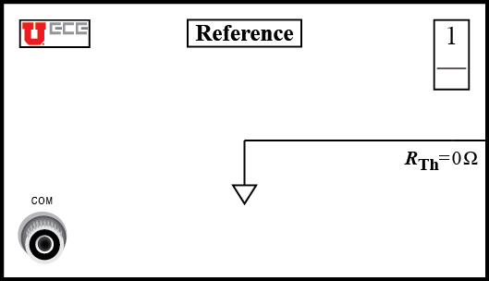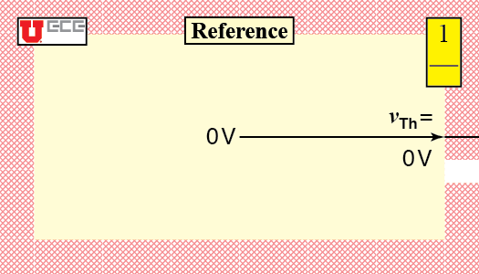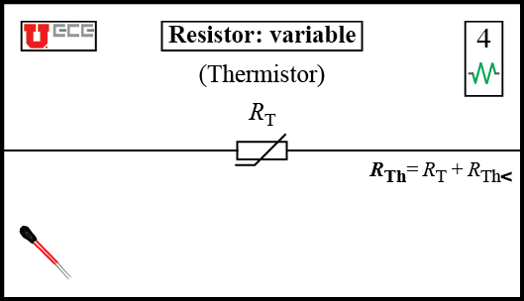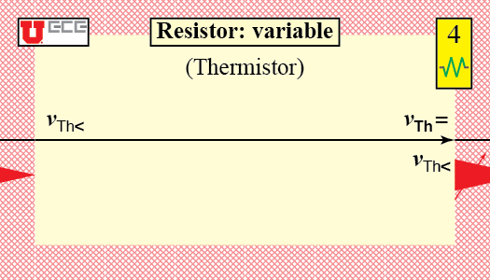
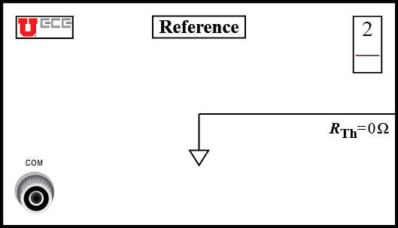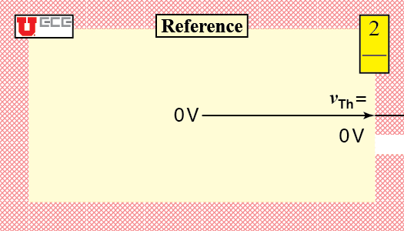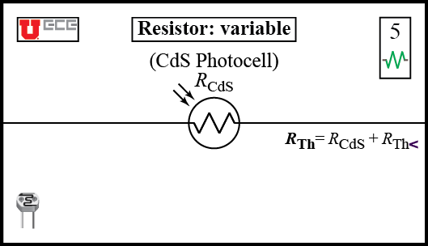
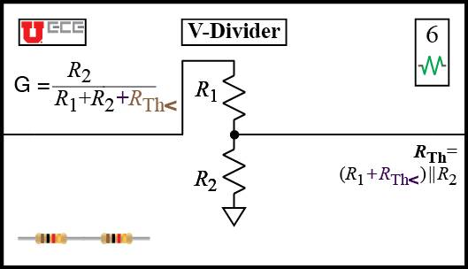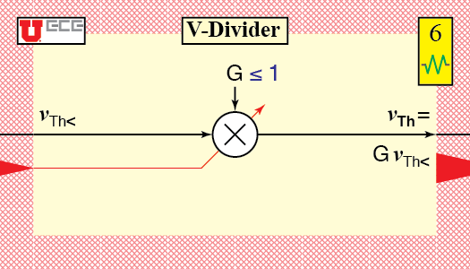
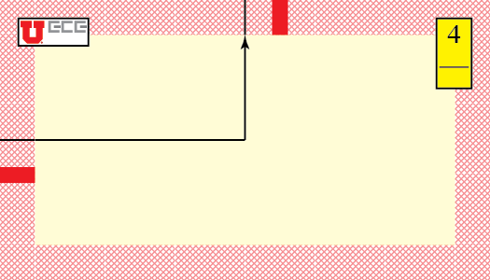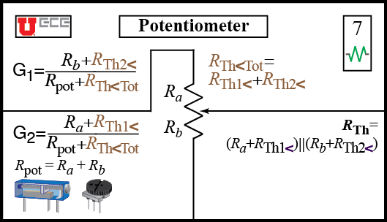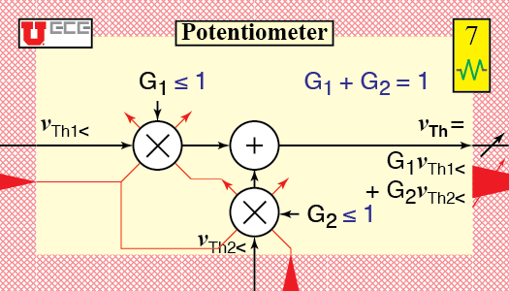
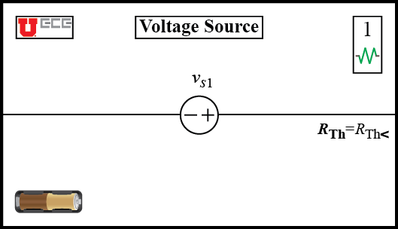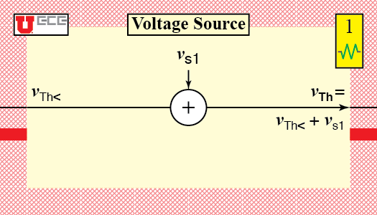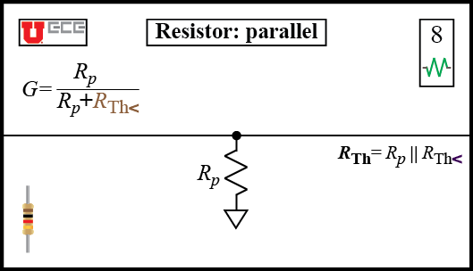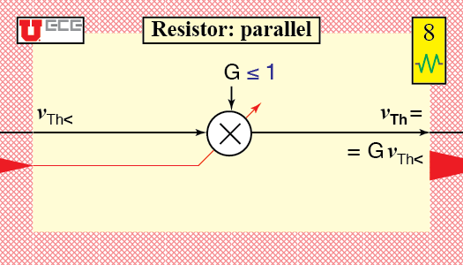
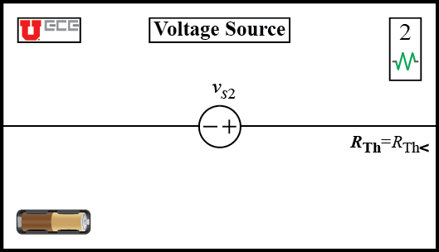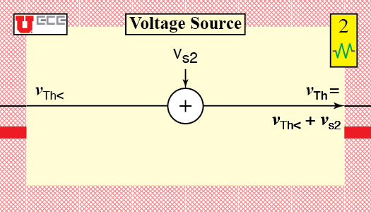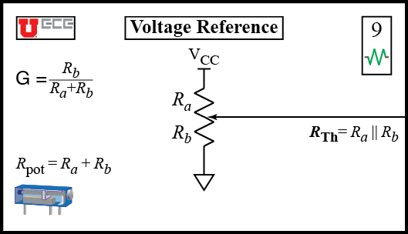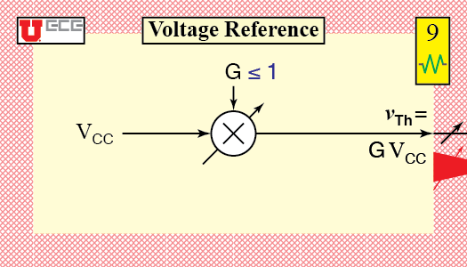
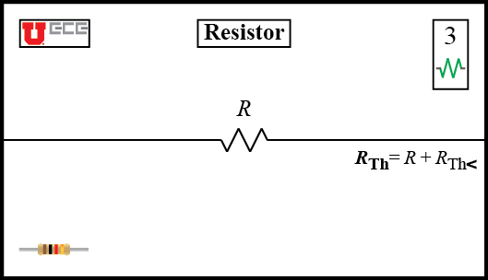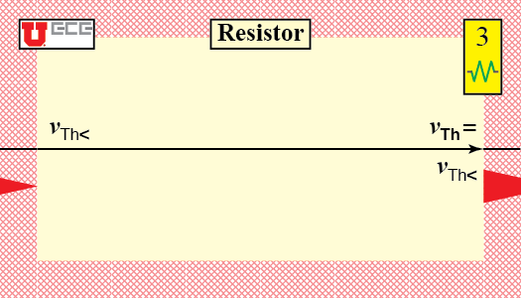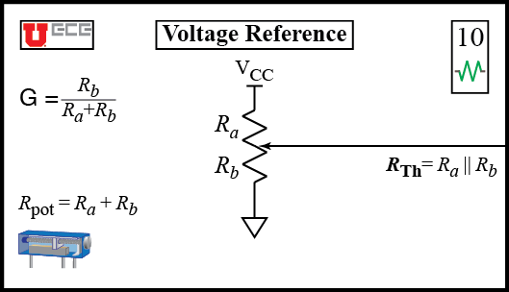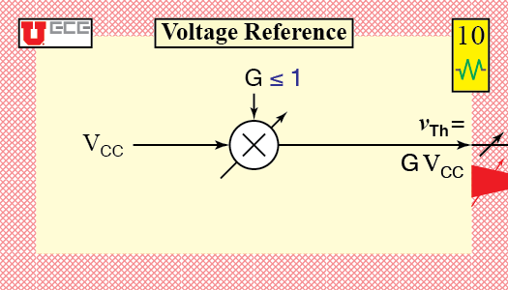
Fig. A1. Circuit System Design card catalog: Wire and Component cards. Circuit side with white background. System side, with yellow background.

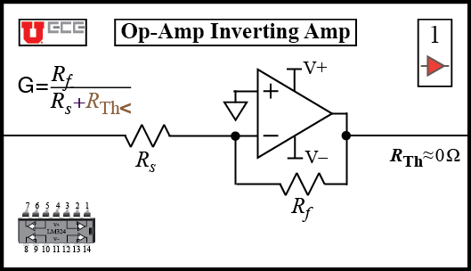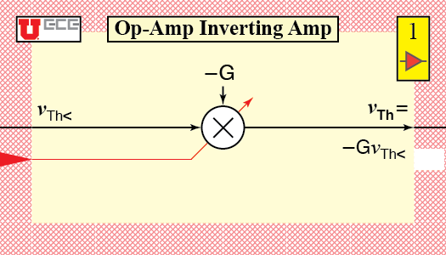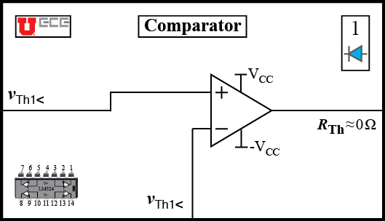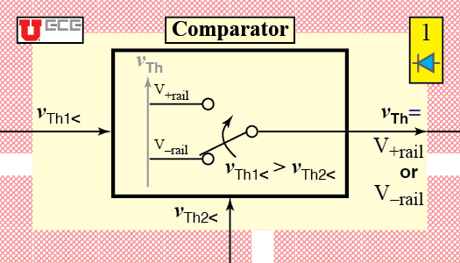
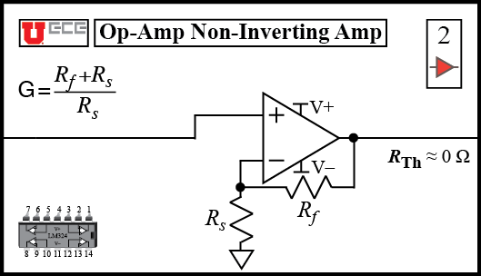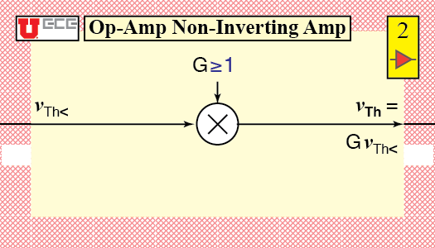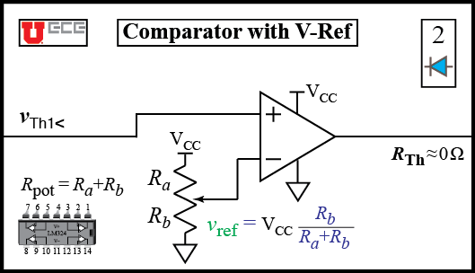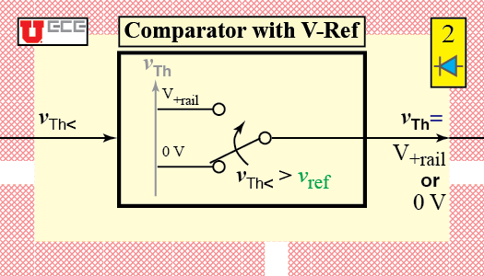
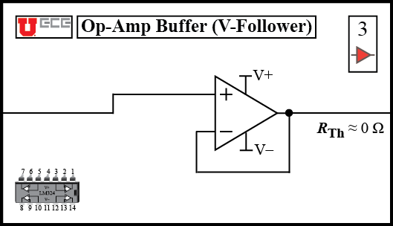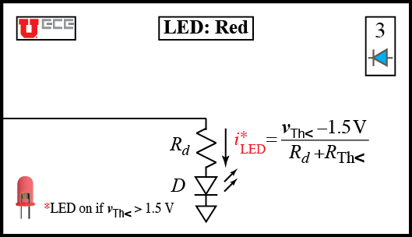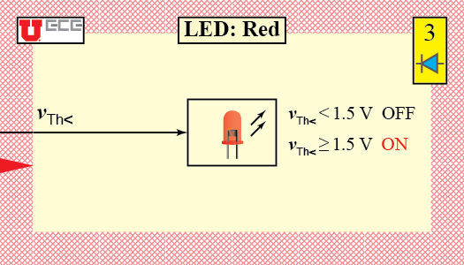
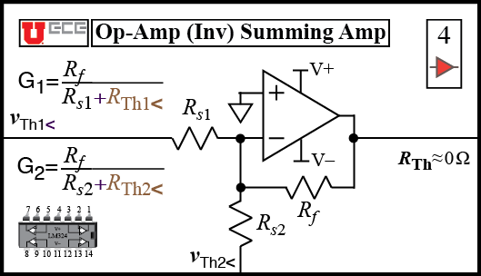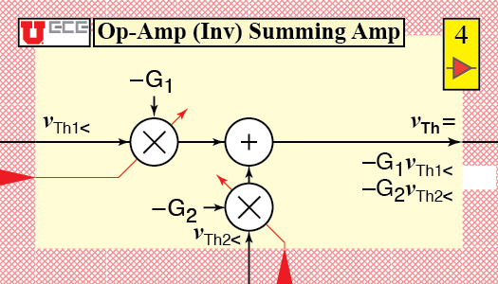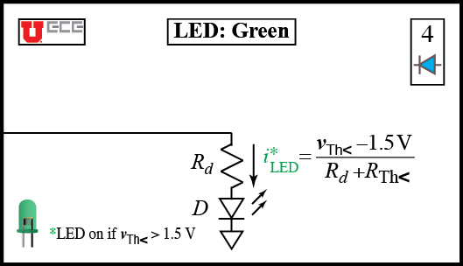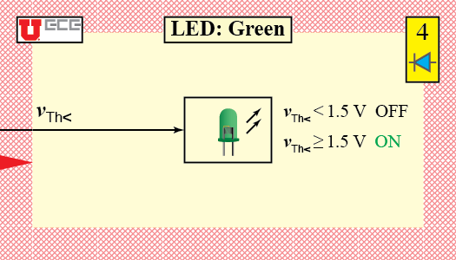
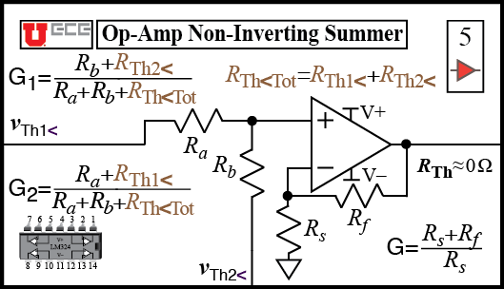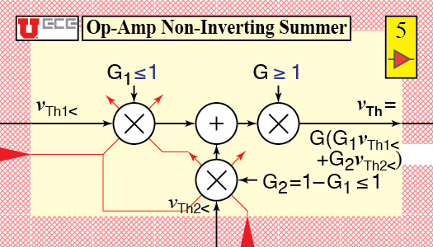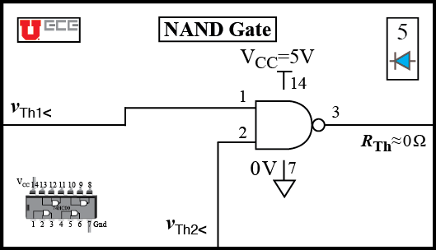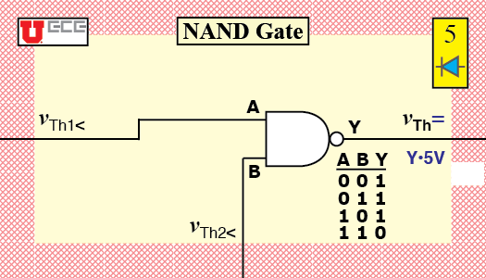
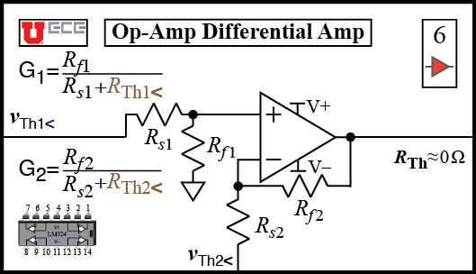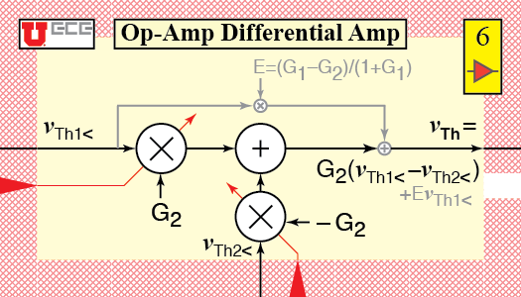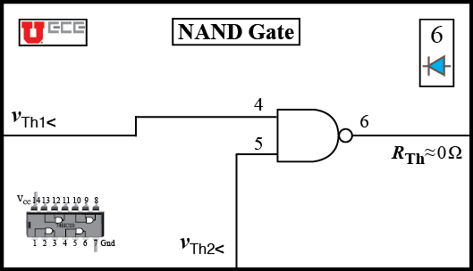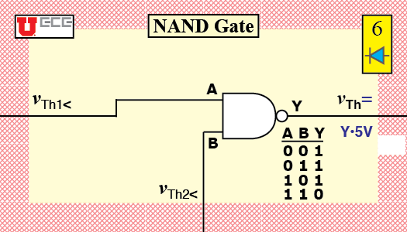
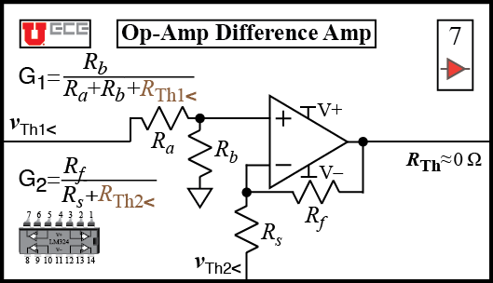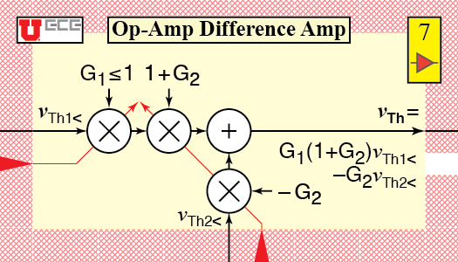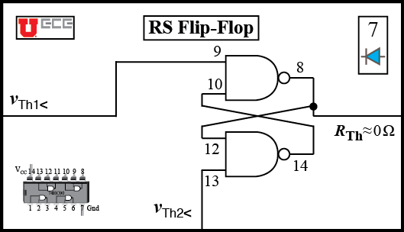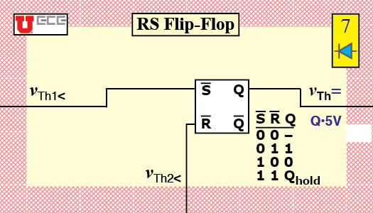
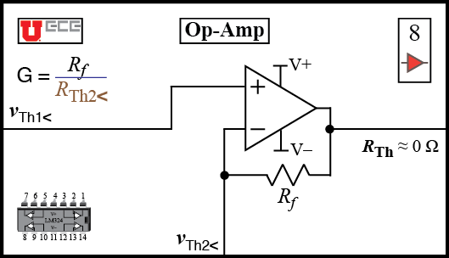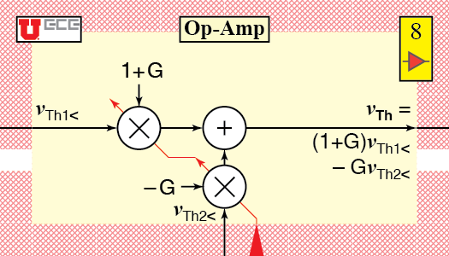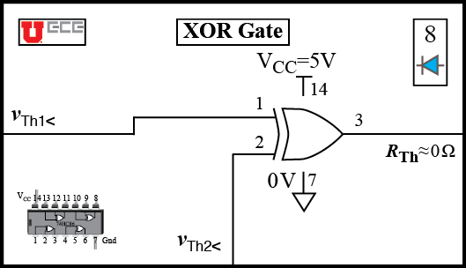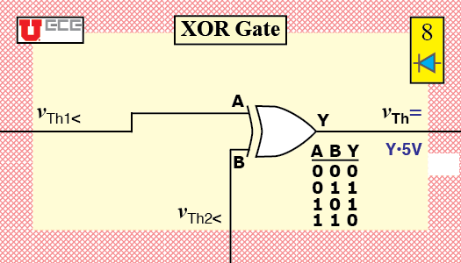
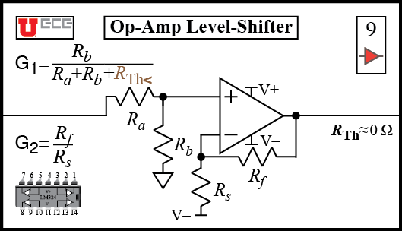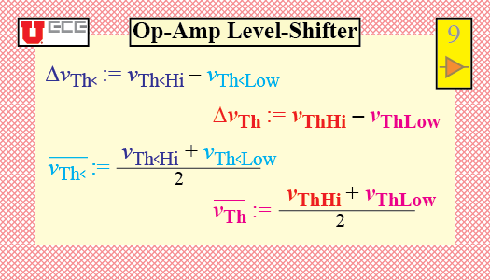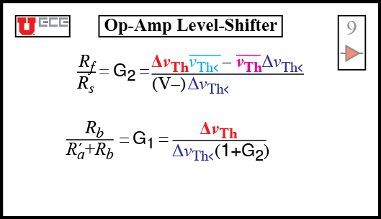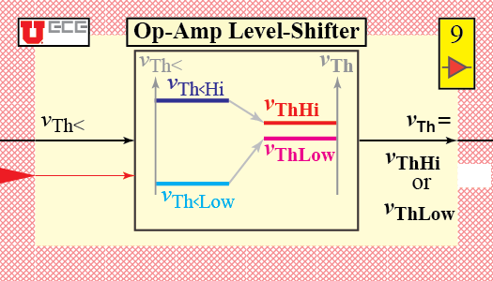
Fig. A2. Circuit System Design card catalog: Amplifier and Gate cards. Circuit side with white background. System side, with yellow background.

N. E. Cotter is with the Electrical and Computer Engineering Dept., University of Utah, Salt Lake City, UT 84112 USA (phone 801-581-8566, e-mail: necotter@ece.utah.edu). C. Furse is with the Department of Electrical and Computer Engineering, University of Utah, Salt Lake City, UT 84112-9206 USA and also with LiveWire Test Labs, Inc., Salt Lake City, UT 84117 USA (e-mail: cfurse@ece.utah.edu).

